**Results**

1. Distribution pattern of zooplankton in the Halda river basin

Distribution Of different groups of zooplankton varied according to the stations (Table 1). The major group that dominated the findings are copepod, acetes, shrimp Larvae, crab larvae, mysid, lucifer, amphipod, sagittal. The minor number of daphnia, Fish larvae also found. Total number of zooplankton varied from 2.41 ind/m3 to 62.6 ind/m3 in studied throughout the research period. Among the group copepod comprises the highest amount, accounting of total sample in station -01 but in station -03 shrimp larvae was dominate.

The presence-absence matrix reveals the distribution of zooplankton species across different stations and seasons. The analysis indicates that Mysid, Crab Larvae, Shrimp larvae, Acetes, Daphnia, Fish larvae, Sagitta, Copepod, Lucifer, Amphipod, and Unidentified species were observed in all stations during both monsoon and post-monsoon seasons. However, Daphnia was absent in Station 1 during the monsoon season. The table suggests a relatively consistent presence of most zooplankton species throughout the study area and across both seasons, with limited seasonal and spatial variations in their distribution. Further investigation into the factors influencing the distribution of these species and their potential ecological roles is warranted.

Table 1. Distribution Pattern of Zooplankton in the Halda river (+presence, -absence)

|  |  |  |  |  |  |  |  |
| --- | --- | --- | --- | --- | --- | --- | --- |
| **Groups** |  | **Monsoon** | | | **Post Monsoon** | | |
|  | S1 | S2 | S3 | S1 | S2 | S3 |
| Mysid |  | + | + | + | + | + | + |
| Crab Larvae |  | - | + | + | + | + | + |
| Shrimp larvae |  | + | + | + | + | + | + |
| Acetes |  | + | + | + | + | + | + |
| Daphnia |  | + | + | + | + | + | + |
| Fish larvae |  | + | + | + | + | + | + |
| Sagitta |  | + | + | + | + | + | + |
| Copepod |  | + | + | + | + | + | + |
| lucifer |  | - | + | + | + | + | + |
| Amphipod |  | - | + | + | + | + | + |
| Unidentified |  | + | + | + | + | + | + |

1. Seasonal abundances of zooplankton in the Halda river, Bangladesh

The abundance of zooplankton was comparatively higher during post- monsoon than monsoon and post-monsoon (Figure 2). In this pre-monsoon, the total number of zooplankton was 315. During monsoon, the total number of zooplankton was 441 and 221 of zooplankton was observed during post-monsoon. Relative abundances of zooplankton showed the percent composition of an organism of a particular kind relative to the total number of zooplankton in the Halda river according to the seasons ( Figures are in supplementary file; figures 2a-c).

The left graph (a) depicts the density of individuals per cubic meter (Number/m³) for various species at three stations (1, 2, and 3) during the monsoon and post-monsoon periods. Notably, abundance is slightly higher in the post-monsoon phase across all stations, with Copepods, Amphipods, and Daphnia as the dominant species, significantly increasing in absolute numbers after the monsoon. Conversely, the right graph (b) illustrates the relative abundance of species at the same stations across both seasons. Each bar's total height represents 100%, with species occupying proportional segments. While absolute abundance varies in graph (a), the relative species composition remains largely stable, although some species, such as Daphnia and Amphipods, exhibit minor fluctuations in their proportions. In summary, the post-monsoon period witnesses a notable rise in absolute individuals per cubic meter compared to the monsoon season, with Copepods, Amphipods, and Daphnia continuing to dominate, albeit with slight shifts in relative abundances. Unidentified species are also recorded, especially at station 3, but account for a minor share of the overall community. Despite the increase in species abundance post-monsoon, the overall relative composition remains fairly consistent across stations and seasons.

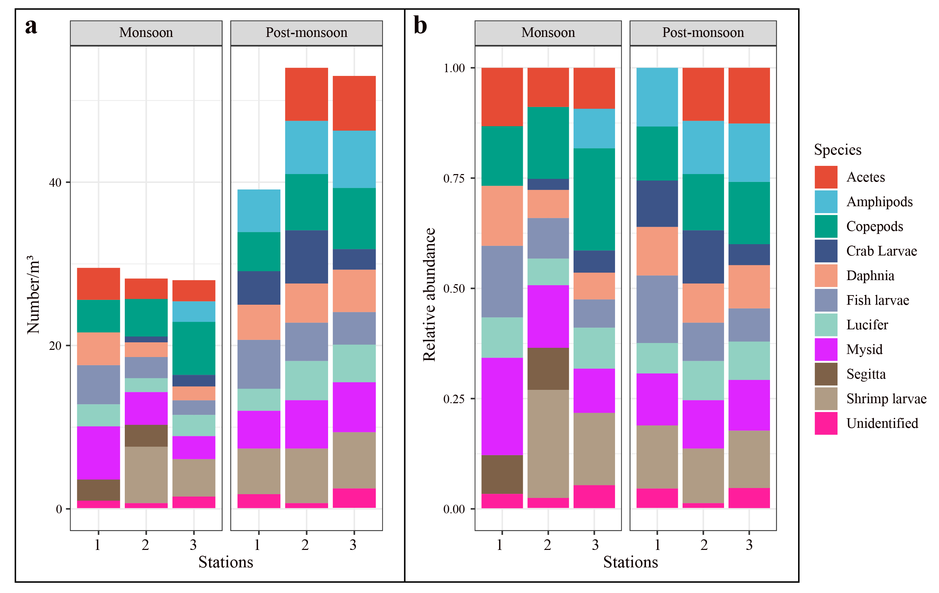

Figure 2. The number of zooplankton per meter cube (a) and their relative abundance (b) according to the stations and seasons.

* 1. Abundances of zooplankton during monsoon seasons over the three stations (Brief writeup for the table is needed) [I think table is not needed as graph nicely depicts all the things]

Table 2. Zooplankton distribution over the monsoon seasons

| Station | St1 | | | St2 | | | St3 | | |
| --- | --- | --- | --- | --- | --- | --- | --- | --- | --- |
| Taxon | Ind/Haul | Ind/m3 | Relative abundances (%) | Ind/Haul | Ind/m3 | Relative  abundances (%) | Ind/Haul | Ind/ m3 | Relative abundances (%) |
| Fish Larvae | 23 | 4.8 | 19.34 | 13 | 2.6 | 9.49 | 8 | 1.8 | 6.0 |
| Copepod | 18 | 4 | 19.34 | 21 | 4.6 | 15.33 | 31 | 6.5 | 23.48 |
| Segitta | 11 | 2.6 | 9.24 | 14 | 2.7 | 10.22 | 12 | 2.5 | 9.09 |
| Daphnia | 17 | 4.0 | 14.28 | 9 | 1.8 | 6.57 | 7 | 1.7 | 5.30 |
| Acetes | 16 | 3.9 | 13.46 | 11 | 2.5 | 8.03 | 14 | 2.6 | 10.61 |
| Crab Larvae | 0 | 0 | 0 | 3 | 0.7 | 2.19 | 5 | 1.4 | 3.79 |
| Mysid | 29 | 6.5 | 24.37 | 18 | 4.0 | 13.19 | 16 | 2.8 | 12.12 |
| Shrimp larvae | - | - | - | 38 | 6.9 | 27.74 | 21 | 4.6 | 15.91 |
| Lucifer | - | - | - | 7 | 1.7 | 5.11 | 12 | 2.6 | 9.09 |
| amphipod | - | - | - | - | - | - | 12 | 2.5 | 9.09 |
| Unidentified | 5 | 1.0 | 4.21 | 3 | 0.7 | 2.19 | 6 | 1.5 | 6.82 |
| **Total** | - | **26.8** | - | - | **27.5** | - | - | **27.8** | - |

* 1. Abundances of zooplankton during post-monsoon seasons over the three stations (Brief writeup for the table is needed)

Table 3. Zooplankton distribution over the post-monsoon seasons

| Station | St1 | | | St2 | | | St3 | | |
| --- | --- | --- | --- | --- | --- | --- | --- | --- | --- |
| Taxon | Ind/Haul | Ind/m3 | Relative abundances (%) | Ind/Haul | Ind/m3 | Relative  abundances (%) | Ind/Haul | Ind/ m3 | Relative abundances (%) |
| Fish Larvae | 28 | 6 | 14.14 | 26 | 4.7 | 10.53 | 18 | 4 | 7.64 |
| Copepod | 22 | 4.8 | 11.11 | 32 | 6.9 | 12.96 | 54 | 7.5 | 19.64 |
| Segitta | - | - | - | - | - | - |  |  |  |
| Daphnia | 20 | 4.3 | 10.10 | 22 | 4.8 | 8.91 | 25 | 5.2 | 9.09 |
| Acetes | 21 | 4.6 | 10.6 | 28 | 6.5 | 11.33 | 31 | 6.7 | 11.27 |
| Crab Larvae | 17 | 4.1 | 8.58 |  |  |  | 11 | 2.5 | 4.00 |
| Mysid | 21 | 4.6 | 10.6 | 27 | 5.9 | 10.93 | 28 | 6.1 | 10.18 |
| Shrimp larvae | 26 | 5.6 | 13.13 | 30 | 6.7 | 12.15 | 37 | 6.9 | 13.45 |
| Lucifer | 18 | 2.7 | 9.00 |  |  |  | 21 | 4.6 | 7.64 |
| amphipod | 24 | 5.2 | 12.12 | 30 | 6.5 | 12.15 | 39 | 7.0 | 14.64 |
| Unidentified | 8 | 1.8 | 4.00 | 3 | 0.7 | 1.21 | 11 | 2.5 | 4 |
| **Total** |  | **43.7** |  |  | **53.8** |  |  | **53** |  |

1. Diversity indices interms of spatial and temporal variation of zooplankton in the Halda river, Bangladesh

The average value of seasonal and spatial Shannon-Weiner diversity index (H’) varied between 1.65 to 1.81 and 1.67 to 1.72, Evenness index (J’) was varied between 3.85 to 4.16 and 3.97 to 3.84 and Species richness (d) varied between and 0.49 to 0.54 and 0.46 to 0.49, respectively during the study period ((Table 4). Spatially, the highest value of Shannon-Weiner (1.72), Species richness (0.49), and Evenness (3.97) was observed at station 1. Seasonally Richness was highest in the monsoon (0.54) and lowest in the post-monsoon (0.49). Diversity was highest in the post-monsoon (1.81) and lowest in the monsoon (1.65).

Evenness was lowest in the monsoon (3.85) and highest in the post-monsoon (4.16) period in the study area.

The boxplot illustrates a comprehensive analysis of biodiversity indices across three stations during the monsoon and post-monsoon seasons, highlighting important ecological dynamics. Pielou's Evenness (J') consistently maintains high values across all stations, suggesting a well-balanced distribution of individuals among species, which is crucial for ecosystem stability. In contrast, Margalef's Richness (d) indicates an increase in species richness during the post-monsoon season, especially at stations 2 and 3, which suggests favorable conditions for species proliferation after monsoonal rains. The Shannon Index (H) shows significant diversity in post-monsoon conditions, particularly at stations 2 and 3, reflecting the presence of a variety of species and their abundance, critical for ecosystem resilience. Conversely, the Simpson Index (1-D) demonstrates a relatively stable community composition, with slight increases observed in the post-monsoon season, indicating a degree of stability amidst seasonal fluctuations. Overall, these findings emphasize the impact of seasonal changes on species abundance and diversity, providing valuable insights for the management and conservation of aquatic ecosystems. The data underscores the need for ongoing monitoring and assessment of these indices to understand better and mitigate the effects of environmental changes on biodiversity. This information is critical for informing conservation strategies aimed at maintaining ecological balance and resilience in the face of climate variability and anthropogenic influences.

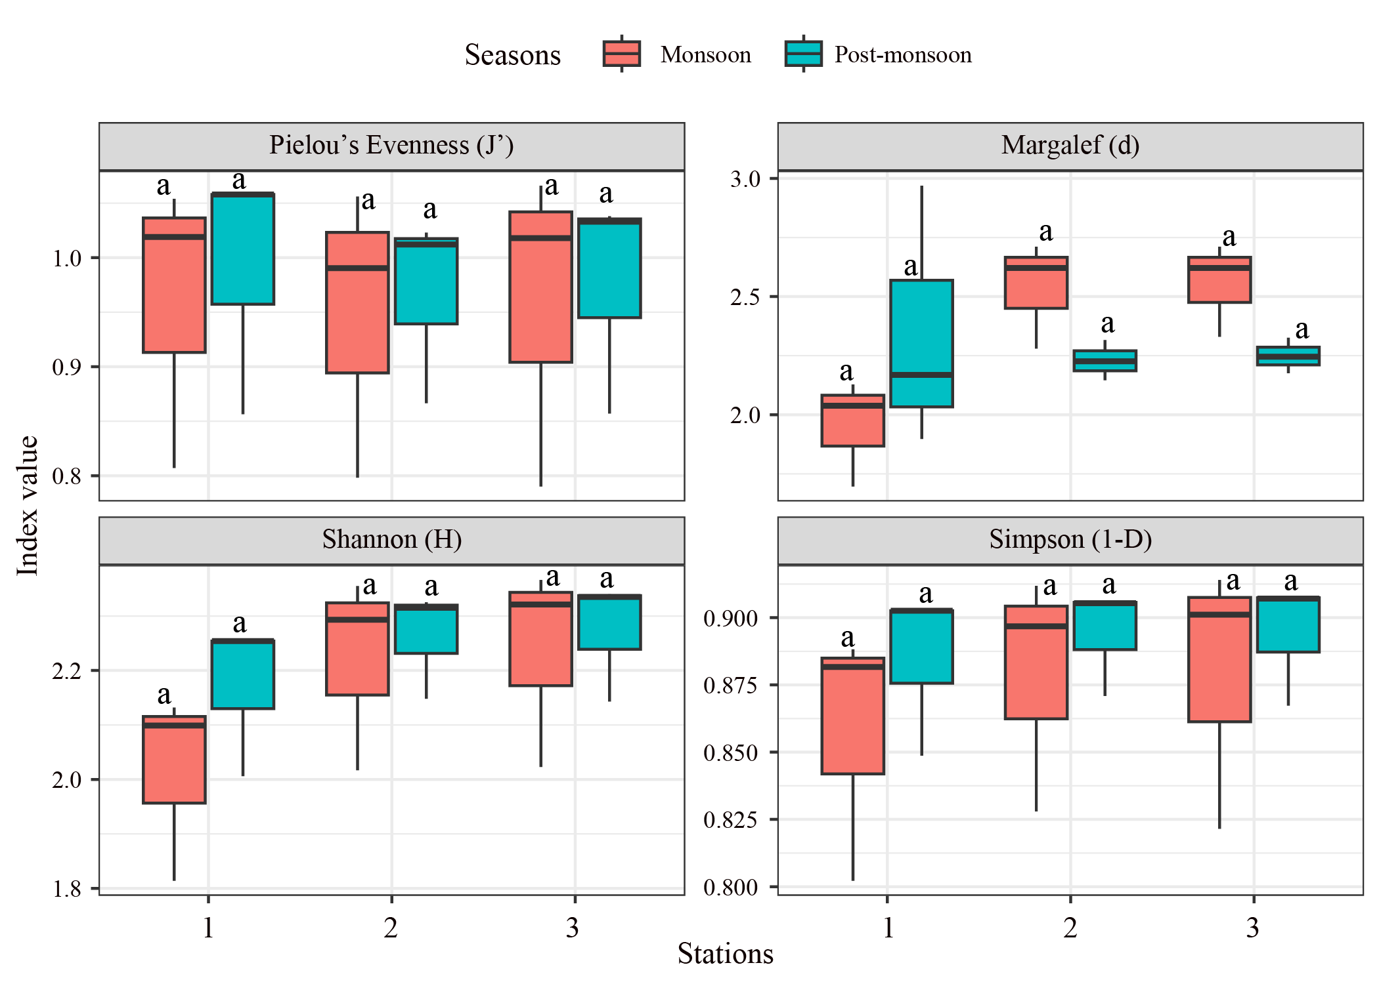

Figure 3. Boxplot showing the Diversity indexes (Pielou’s Evenness (J'), Margalef (d), Shannon (H), Simpson (1-D)) of zooplankton over the seasons (monsoon, post-monsoon). Different letters above the boxplot depicts the significant difference (Two way ANOVA, P < 0.05) between seasons and withing stations.

However, the study have been focused on two-way dendrogram plot to observe the similarity between sites and seasons at the study sites (Figure 4a). (Brief riteup for this segment is needed). Non-parametric Multidimensional scaling (nMDS) ordination of zooplankton clustering on Bray-Curts similarities on square-root-transformed abundance data of the zooplankton communities were also observed (Figure 4b). (Brief writeup for this graph is required).

The left graph (a) depicts a two-way dendrogram that illustrates the similarities among zooplankton communities across different stations and seasons. This hierarchical clustering is based on Bray-Curtis similarities, utilizing square-root-transformed abundance data. The dendrogram clearly delineates groupings, indicating that the composition of zooplankton communities is significantly influenced by seasonal environmental conditions. Close affinities among various stations underscore the interconnectedness of these communities, suggesting that ecological factors are driving the observed patterns. In the right graph (b), the non-metric multidimensional scaling (nMDS) ordination further elucidates these findings, demonstrating how zooplankton communities cluster along the NMDS axes. With a stress value of 0.00, this plot indicates a remarkably high level of separation between monsoon and post-monsoon seasons. The distinct clustering of samples by season reinforces the dynamic nature of zooplankton assemblages and highlights how environmental fluctuations during different periods lead to significant shifts in community structure. However, the pronounced spatial separation between the seasons suggests that ecological interactions and resource availability differ markedly, influencing species distribution and abundance. These results offer compelling evidence of the complex interplay between seasonal changes and zooplankton diversity, providing critical insights into aquatic ecosystem dynamics and resilience. Understanding these relationships is essential for effective management and conservation strategies, particularly in the context of environmental change.

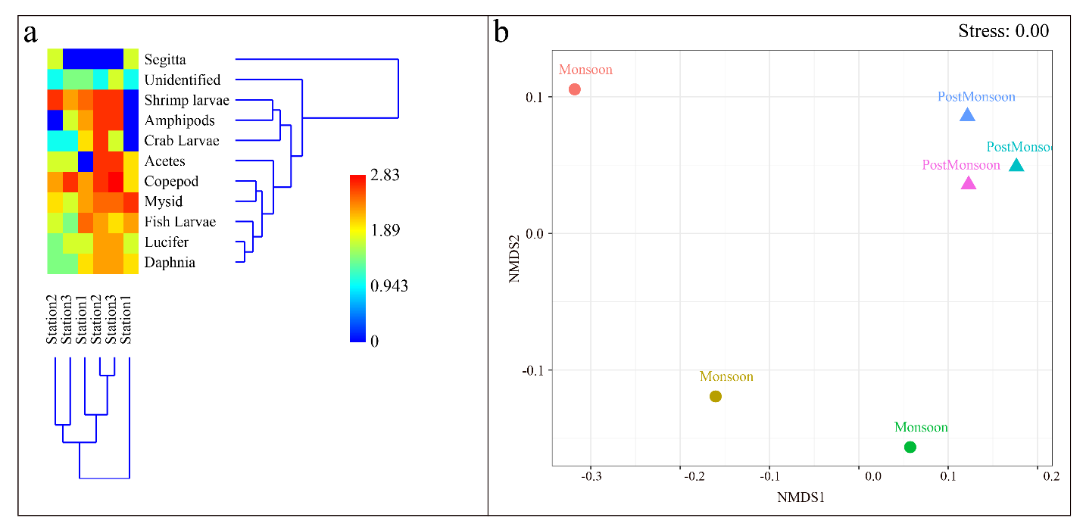

Figure 4a. Two-way dendrogram plot showing similarity between sites and seasons 4b. non-parametric multidimensional scaling (nMDS) ordination of zooplankton clustering on Bray-Curts similarities on square-root-transformed abundance data of the zooplankton communities among seasons ith 0.00 stress.

1. Influence of environmental parameters and their relationship with zooplankton at the Halda river.
   1. Environmental parameters in the Halda river basin

During monsoon the temperature ranges between 21⁰C to 28⁰C. Highest temperature was collected from station -3. During 2nd sampling in post monsoon temperature ranges between 25⁰C to 28⁰C. Highest temperature range was recorded in station-03. Water pH was ranges between 6.8 to 7.2 during monsoon. Highest pH was recorded in station 03. In past monsoon PH was recorded between 7.0 to 7.3 highest value was found again at station 03 (Table 02). Water salinity, DO……………….? Environmental variables from the collected sites are given in table 5.

Table 6. Environmental variables from the study sites

| Station | St1 | | St2 | | St3 | |
| --- | --- | --- | --- | --- | --- | --- |
| Environmental variable | Monsoon | Post-monsoon | Monsoon | Post-monsoon | Monsoon | Post-monsoon |
| Water temperature (°c) | 24.83±0.42 | 26.6±0.46 | 25.03±0.4 | 26.03±0.68 | 25.2±0.78 | 26.6±0.36 |
| Water PH | 6.77±0.15 | 7.37±0.21 | 6.8±0.44 | 7.17±0.32 | 6.7±0.4 | 7.07±0.15 |
| Water Salinity (ppt) | 0.57±0.32 | 0.43±0.31 | 0.4±0.26 | 0.67±0.25 | 0.67±0.21 | 0.8±0.1 |
| DO (mg/l) | 7.6±0.8 | 6.8±0.56 | 6.03±0.58 | 7.13±1.12 | 6.27±0.68 | 7.3±0.9 |

The boxplot representation revealed significant temporal and spatial variations in water quality parameters across the study area. Dissolved oxygen (DO) levels were notably higher during the monsoon season compared to the post-monsoon season, likely due to increased rainfall and runoff. Spatial variations in DO were also observed, with Station 2 exhibiting consistently lower levels, potentially influenced by localized factors such as pollution or restricted water flow. Salinity levels demonstrated an opposite trend, increasing significantly in the post-monsoon season due to reduced freshwater input and increased evaporation. Station 3 consistently exhibited higher salinity levels, suggesting its proximity to a saline source or greater influence from tidal waters. pH remained relatively stable across both seasons and stations, indicating consistent environmental conditions. Temperature levels increased significantly in the post-monsoon season due to reduced cloud cover and increased solar radiation, but no significant spatial variations were observed. These findings underscore the importance of considering both seasonal and spatial factors when assessing water quality in the study area. Further investigation into the underlying causes of these variations would be beneficial for understanding the ecological implications and developing effective water management strategies

---

The revised paragraph maintains clarity and flow while enhancing the overall quality of the writing.

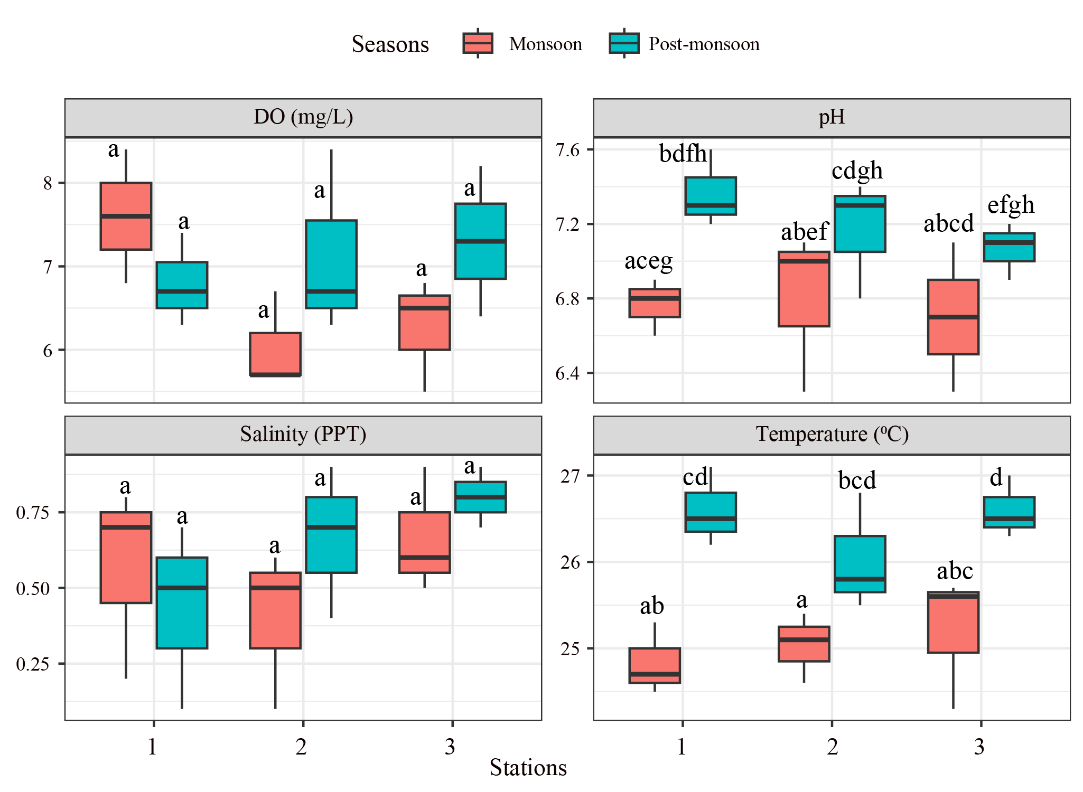

Figure 5. The temporal variation of water quality parameters. Different letters above the boxplot depicts significant difference (Two way ANOVA, P < 0.05) between two seasons and three stations with ten observation each (n = 5). Differrent (what does mean by bdfh………………………bc…explaination = Different letters depict the significant difference among the mean parameters of between seasons and within stations) (brief writeup is missing)

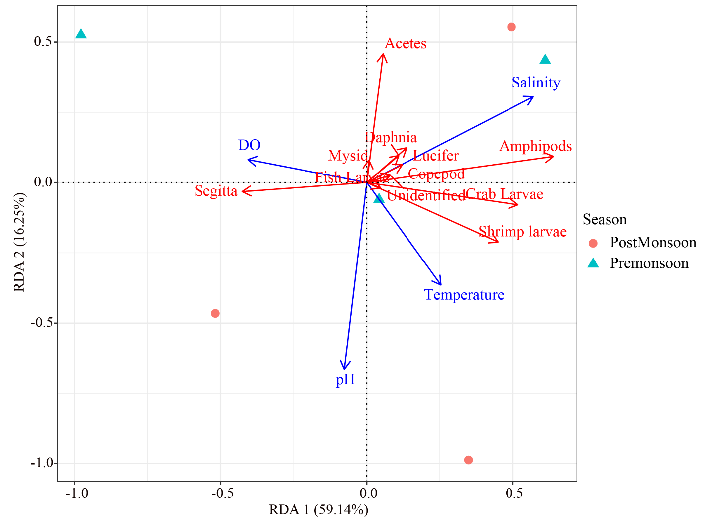Figure 6. Relationship between environmental factors and zooplankton communities: a redundancy analysis of zooplankton dominant genus and the relation with water quality parameters, the vectors represent the most correlating water quality parameters (p <0.05). Brief writeup of the graph need to be added

The redundancy analysis (RDA) plot reveals the intricate relationships between environmental factors and zooplankton communities. Salinity emerges as the dominant driver of zooplankton distribution, with a strong positive correlation with Acetes and a negative correlation with Segitta. Temperature also plays a pivotal role, positively correlating with Amphipods and negatively correlating with Daphnia and Mysid. DO, pH, and Lucifer exhibit less pronounced correlations with zooplankton communities. The seasonal fluctuations in environmental factors likely contribute significantly to the observed shifts in zooplankton composition, with post-monsoon conditions favoring species adapted to higher salinity and temperature, while Pre-monsoon conditions may be more suitable for species adapted to lower salinity and temperature.

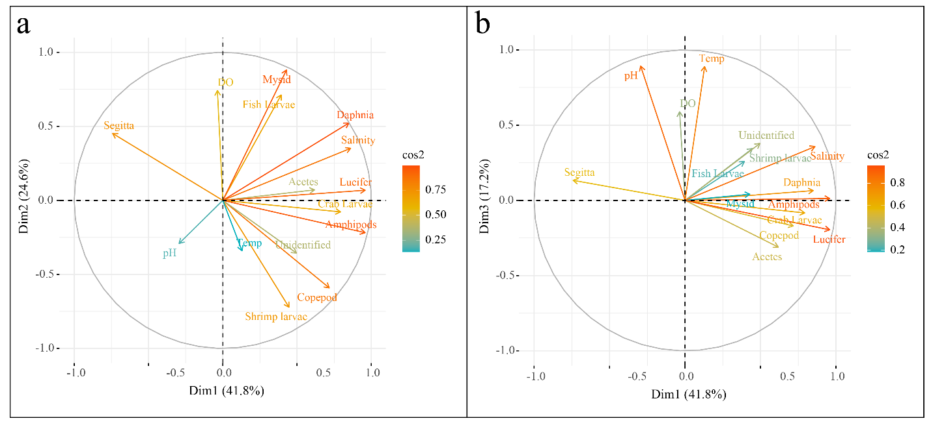Figure 7. Biplot with correlation circle from principal component analysis (PCA) of water quality parameters and zooplankton abundance data: axes 1-2 (a); axes 1-3 (b). The quality of the representation of the quantitative variables is indicated by the cos2 value. pH: hydrogen potential, Temperature (°C), salinity (ppt), DO: dissolved oxygen concentration (mg/L). The quality of the representation of the variables on the graph is indicated by the squared cosine of the variables (cos 2).(Witeup for this graph is needed)

The PCA biplot provides a comprehensive overview of the relationships between water quality parameters and zooplankton abundance data. The correlation circle highlights the relative importance of each variable in explaining the observed variation. Dim1, accounting for 41.8% of the total variance, is primarily driven by salinity and temperature. Dim2, explaining 24.6% of the variation, is associated with pH and dissolved oxygen (DO). Dim3, capturing 17.2% of the variance, is primarily influenced by DO. The biplot further reveals the associations between zooplankton species and environmental factors. Acetes and Amphipods demonstrate a strong positive correlation with salinity and temperature, while Segitta and Daphnia exhibit a negative correlation with these factors. These findings underscore the dominant influence of salinity and temperature on the zooplankton community structure in the study area, suggesting that changes in these environmental factors may have significant implications for the overall aquatic ecosystem.

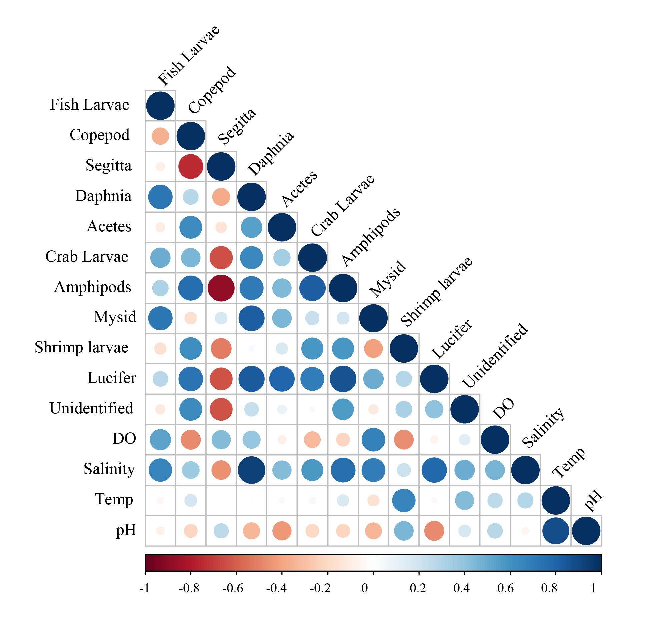

Figure 8. Correlations between zooplankton communities with environmental variables, color gradient corresponds to spearman correlation coefficients between environmental indicators. (writeup for this graph is needed)

The correlation matrix reveals the relationships between zooplankton communities and environmental variables. The color gradient represents the Spearman correlation coefficients between environmental indicators. The results indicate significant positive correlations between salinity and Acetes, Amphipods, and Crab larvae, suggesting their preference for higher salinity conditions. Temperature exhibits positive correlations with Amphipods and Crab larvae, while negative correlations with Daphnia and Segitta, suggesting their sensitivity to temperature changes. Dissolved oxygen (DO) shows weak correlations with zooplankton communities, indicating its limited influence on their distribution. pH exhibits mixed correlations, with positive associations with Mysid and Shrimp larvae and negative associations with Fish larvae and Copepod. Overall, the analysis highlights the complex interplay between zooplankton communities and environmental factors, with salinity and temperature emerging as key drivers of species distribution in the study area.